Activity 1

* Build the following views in your Android.
* Build the views in Creatly.com

Use the following approach: create xml and apply your design

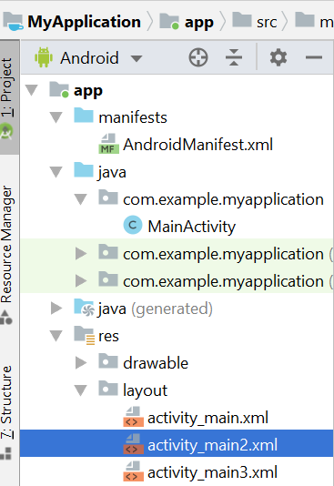

\*\*\* You may not be able to build exactly as it is shown here (do your best – as close as possible)

